Name : Kritika Sharma
Section – 4
ASSIGNMENT 2

- Create a new project/solution
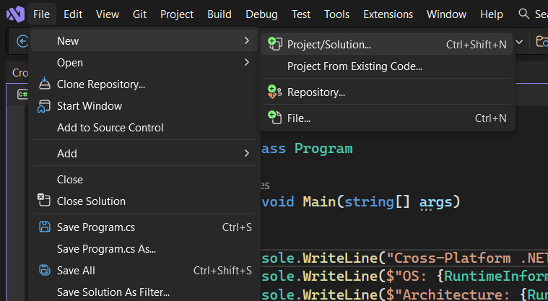

- Write project name and click next
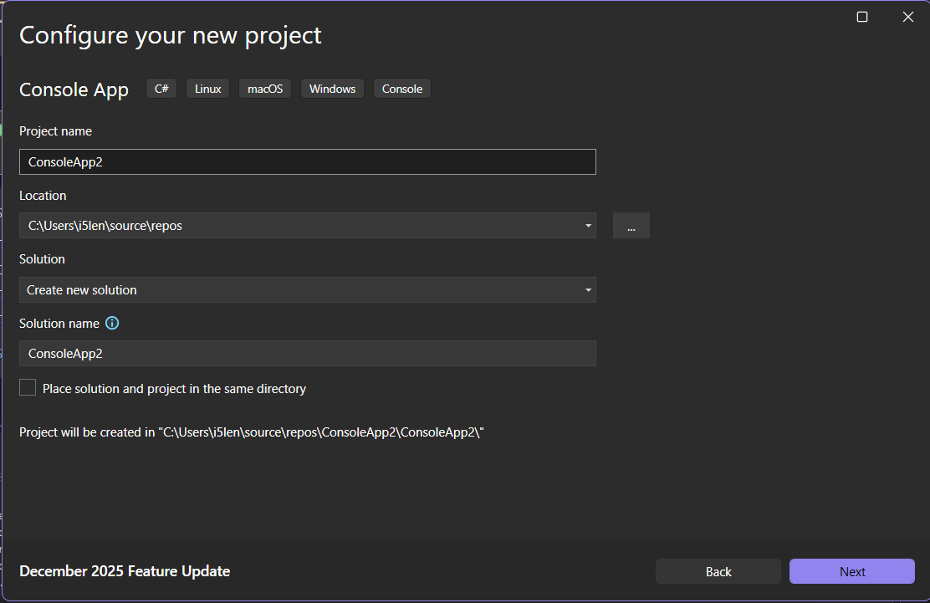

- Select Do not use top-level statement as per need and then click create
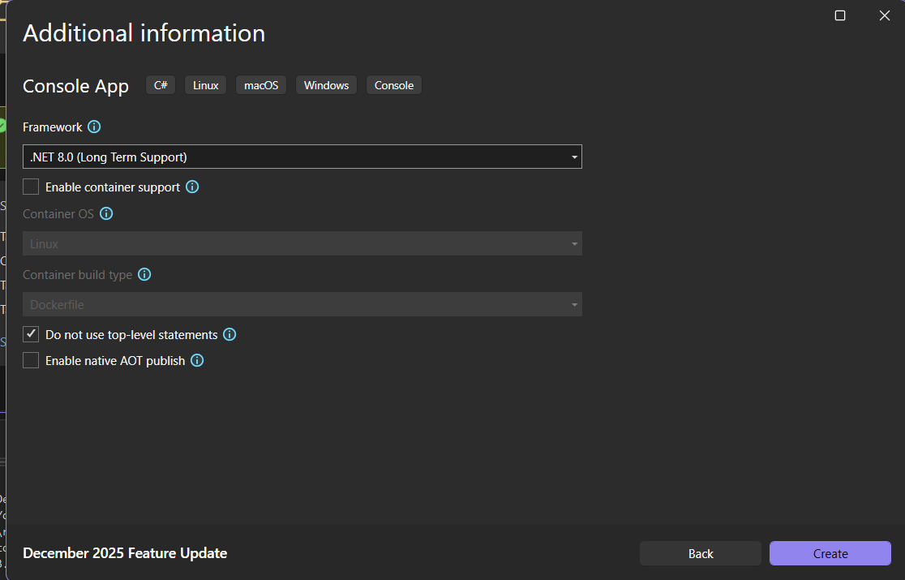
- Write this code to see OS description and architecture
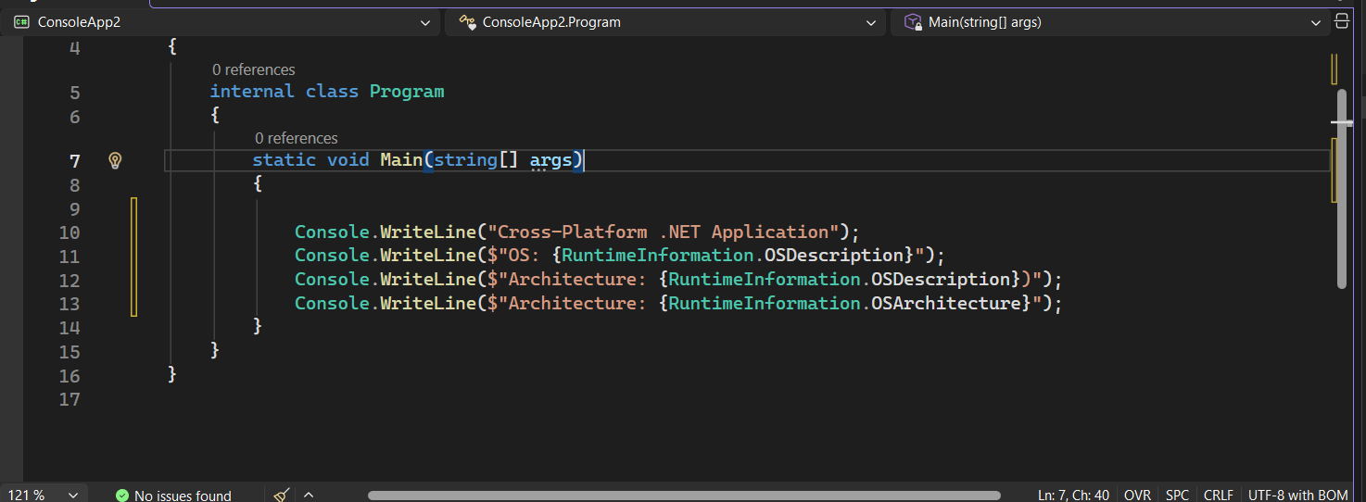
- Output is visible in console
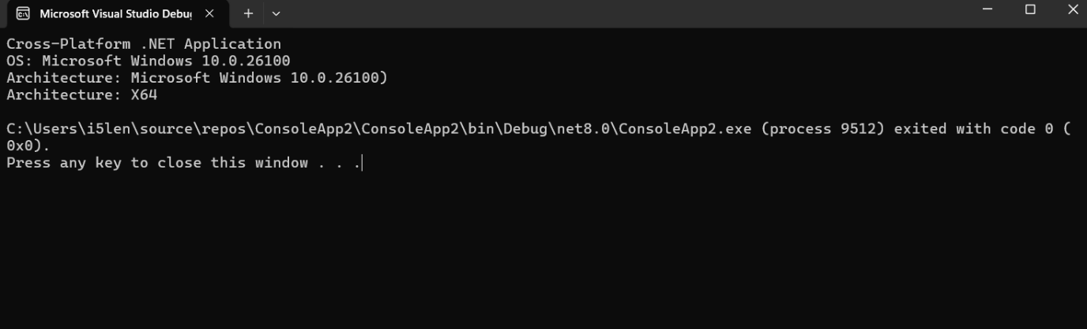
- Right click on project name in solution explorer and select publish
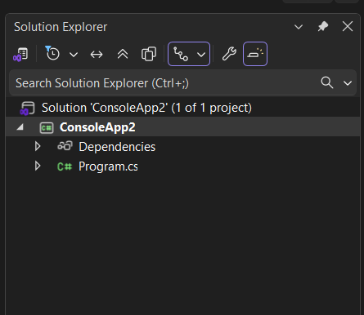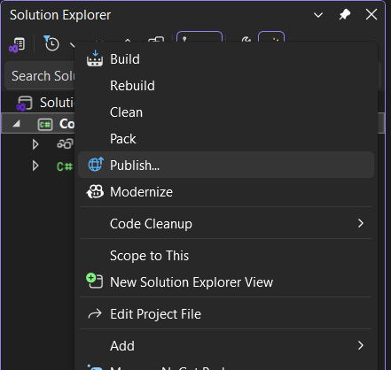

- Select Folder to publish it locally on folder and select next
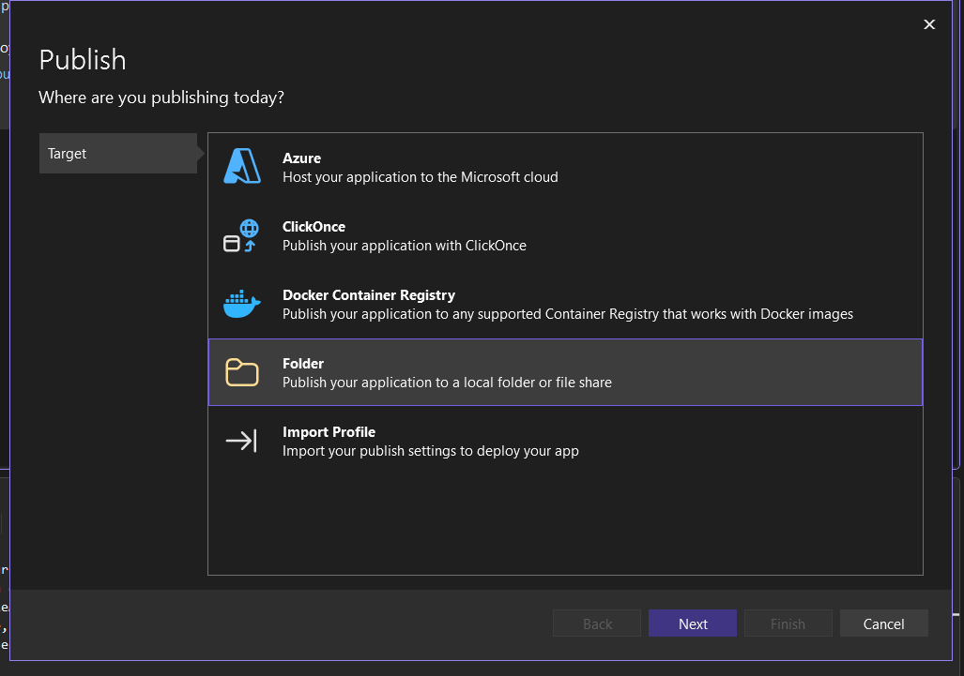

- Select folder and click next
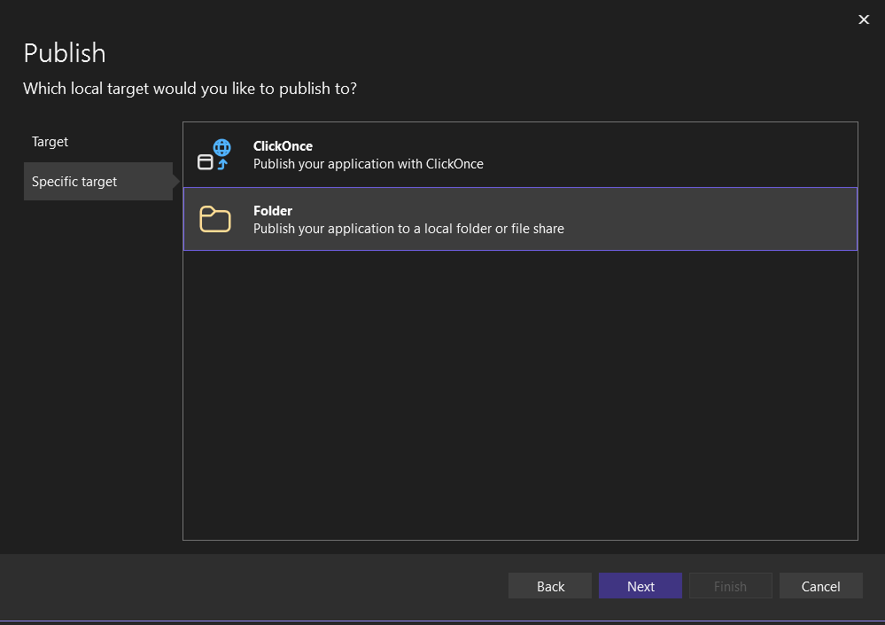

- browse folder location and click finish
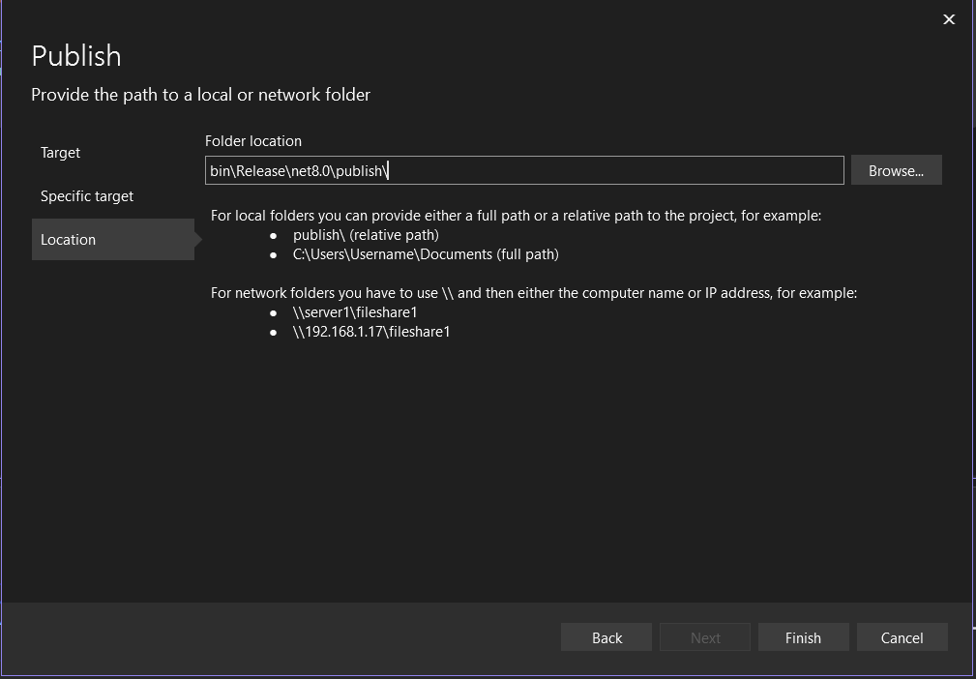

- publish profile is created
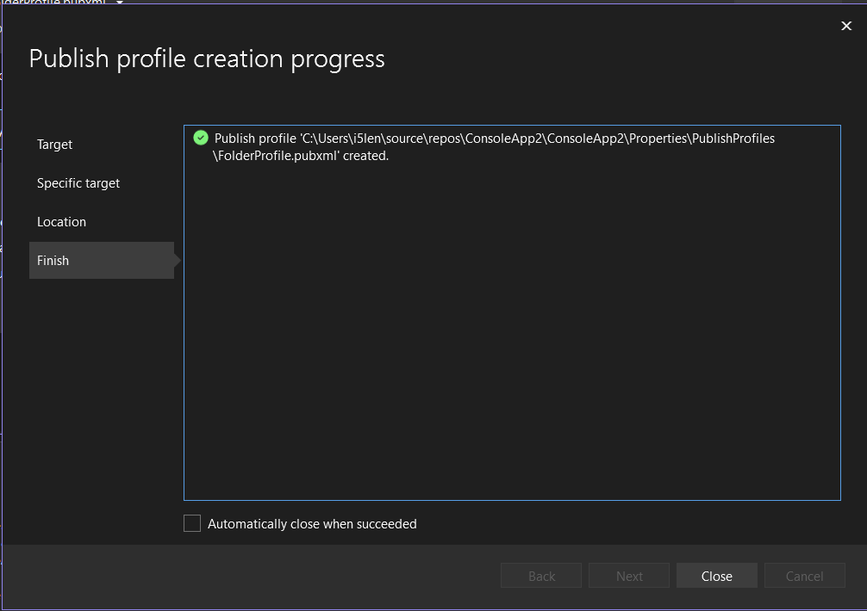
- from more actions click on edit to edit profile
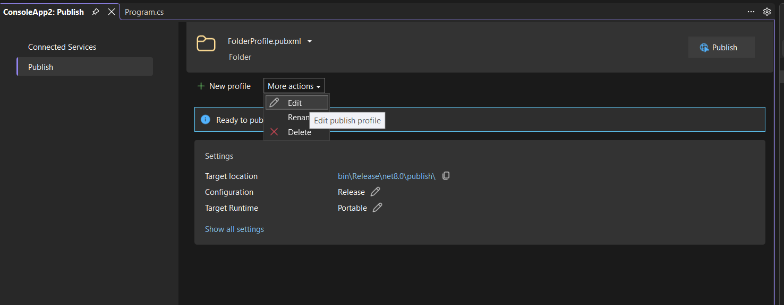
- Deployment mode can be chosen based on requirement
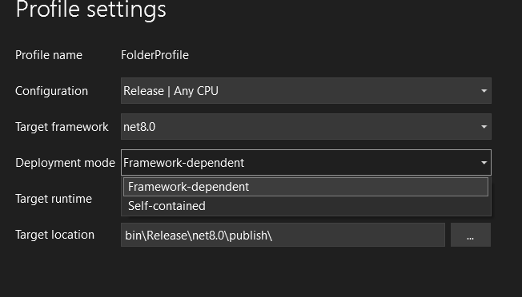
- Choose target runtime from dialog box and save

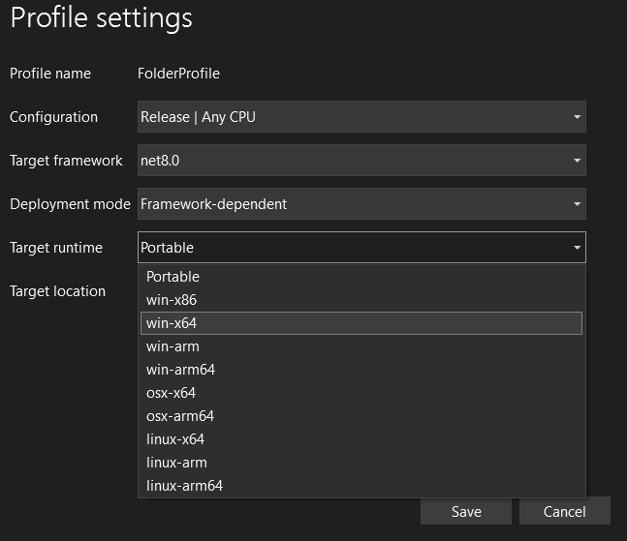

- Click on publish and it will be published
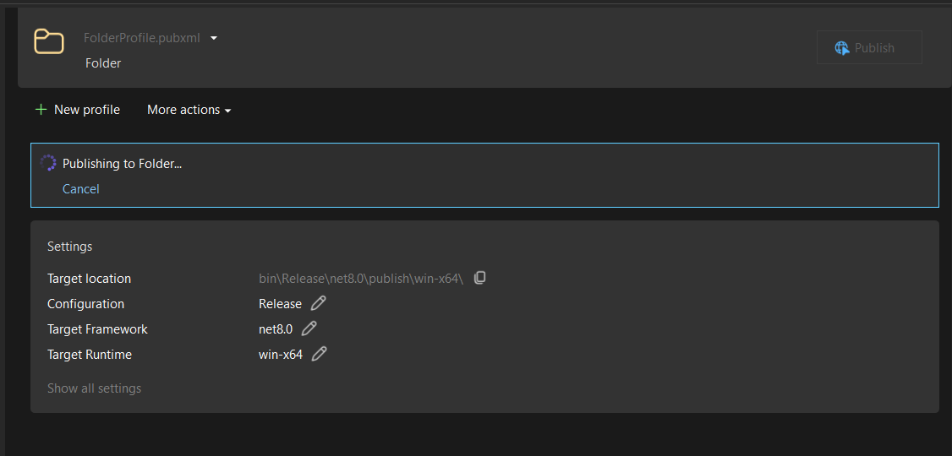

- Trace address and there you can find folder and files.
